● What is the research goal?

The goal of this project was to develop a fully functional conversational AI-ML system.

Create an AI chatbot that can converse constructively with the user and recommend useful solutions.

The chatbot offers the user real-time conversational therapy as well as mental health diagnoses.

● What question(s) is the author trying to answer?

The author trying to solve the problem which mental health and depressed people face during their life

● What methods are being applied?

A dataset of emotions/text was trained using an ML model, specifically the Logistic Regression Model.

● What methods is the author applying to answer the question?

● What are the research results?

The dataset used contains the same 34,792 tweets as the initial dataset considered. As shown in Table 3, each tweet in the dataset is classified into one of eight emotional categories: joy, sadness, neutral, anger, shame, disgust, surprise, and fear. This was used to train the LR model, which was then used to categorise user text into emotions.

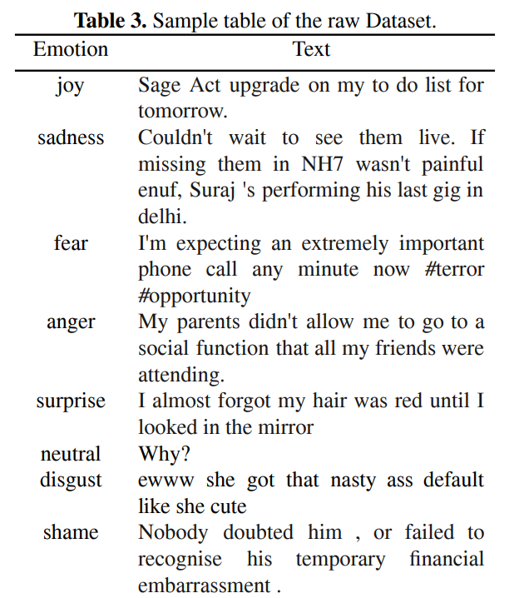

Using the trained LR Model, a classification report and confusion matrix was generated to find the best case for therapeutic conversations.

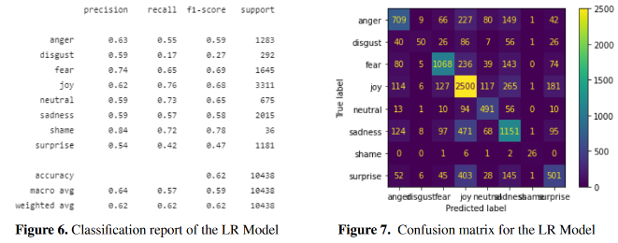

● How are these claims supported?

● For theoretical papers, what results are proven?

Chatbots can be helpful in providing therapy to those who are hesitant to share their emotional issues with another human being. As a result, they concluded that simulated therapy delivered by a chatbot may improve access to mental health care while also being more effective for those who are hesitant to communicate with a therapist.

● What reasonable claims and results are missing from the paper?